BITSAT Maths 2010 Sample Paper Test
The equation of the normal to the circle x2 + y2 = a2 at point (x’ y’) will be :
x’ y – xy’ = 0
xx – yy’ = 0
xy’ + xy’ = 0
xx’ + yy’ = 0
Equation of the bisector of the acute angle between lines 3x + 4y + 5 = 0 and 12x – 5y – 7 = 0 is :
21x + 77y + 100 = 0
99x – 27y + 30 = 0
99x + 27y + 30 = 0
21x – 77y – 100 = 0
Equation to the line passing through the point (-4,5) and perpendicular to 3x = 4y = 7 :
3x-4y+32=0
4x+3y+1= 0
3x+4y-8=0
4x-3y+31=0
If is the angle between two straight lines represented by = 0 then :
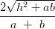
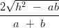
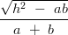
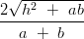
The real part of cos h :
If z = cos i sin then the value of 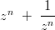will be :
If are the roots of the equation – 2x + 4 = 0 then the value of will be :
is equal to :
If A is a skew symmetric matrix of second order and C is a column matrix of second order then CAC is equal to :
[0]
[1]
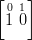
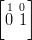
If A = 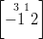and I then the correct statement is :
If A and B are the two matrices of the same order and = (A+B ) (A-B) , then the correct statement will be :
A’B’ = AB
AB=BA
none of these
The value of the determinant 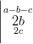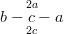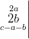will be :
none of these
If + …+ then is equal to :
The term independent of x in the expansion 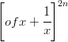is :
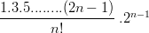
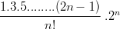
none of these
is equal to :
If n N then m2 is equal to :
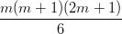
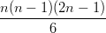
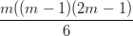
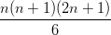
If A.M. and H.M. between two numbers are 27 and 12 respectively then their G.M. is:
9
18
24
36
f 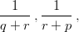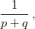are in A.P. then :
p2,q2, r2 are in A.P.
p,q,r are in A.P.
p,q,r are in G.P.
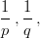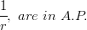
If are the roots of the equation – ax + b = 0 and then :
If 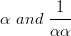are the roots of the equation then k will be:
5
-5
13
1
The value will be :
0
i
– 2 – 2i
2 – 2i
A coin tossed m + n (m > n) , times then the probability that the head appears m times continuosly is :
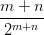
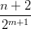
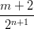
For any two events A and B if P = 5/6, P = 1/3, P(B) = ½ then P(A) is :
½
2/3
1/3
none of these
If M and N are any two events , then the probability of happening exactly one event is:
P(M) + P(N) – P(MN)
P(M) + P(N) – 2P(MN)
P(M) + P(N) + 2P(MN)
none of these
A bag contains 3 white and 5 black balls. One ball is drawn at random. Then the probability that it is black is :
A box contains 100 bulbs, out of these 10 are used. 5 bulbs are choosen at random. Then the probability that no one is fused is :
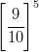
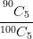
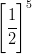
For any two events A and B the correct statement is :
For any non zero vector correct statement is :
then the correct statement is :
out of any two vectors are parallel
are coplanar
any two are equal
at least one above statement is correct
If 0 where are non zero vectors then :
are perpendicular to each other
the angle between
parallel vectors
is unit vector
If 2i + j – k and i – 4j + k are perpendicular to each other then is equal to:
– 3
– 2
– 1
0
If 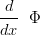(x) = f(x) then f(x) dx is equal to :
If f (a – x) = f(x), then xf(x) dx is equal to :
none of these
f(x)dx = 2 f(x)dx when :
f(2a-x) = – fx
f(2a-x)=f(x)
f(-x)=-f(x)
f(-x)=f(x)
| 1 – x|dx is equal to :
For any integer n the value of (2n+1)x dx will be:
0
1
e
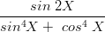dx is equal to :
dx is equal to :
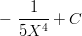
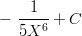
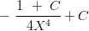
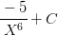
The function sin x + cos x is maximum when x is equal to :
If the normal to a curve is parallel to axis of x, then the correct statement is :
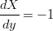
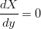
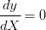
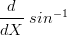x is equal to :
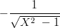
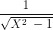
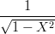
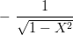
The differential coefficient of is :
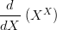is equal to :
[f(x),g(x)] will exist, when :
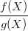is exists
is exists
f (x) or lim g(x) is exists
f (x) and g(x) both exists
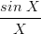is equal to :
2
- 1
1
0
If f(x) = sin [x] , [x] 0 where [x] is a greatest integer less or equal to x then f(x) is equal to :
- 1
0
1
does not exist
If A = {-2, -1, 0, 1,2} and f: such that f(X) = + 1, then the range of f will be:
{1,2,5}
{-2, -1, 0, 1,2}
none of these
The point (at3, at2) will lies on the curve :
The diameter of the circle + 4x – 6y = 0, is :
The pole of the line + my + n = 0 w.r.t. the circle is :
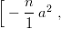
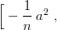
Two dice thrown together then the probability of getting a sum of 7, is :
For any two events A and B, P is equal :
If A and B are two events, then is equal to :
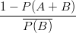
If A then will be :
[0]
A
B
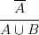is equal :
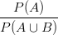
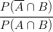
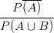
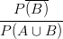
The period of x will be :
equal to :
The angle between the vectors (i+j) abd (j+k) is :
The area of the region bounded by the curves y = x sin x, axis of x, x= 0 and will be :
log sin x dx is equal to :
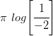
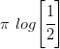
f(x) dx is equal to :
noneof these
sin 2x log tan x dx is equal to :
x dx is equal to :
cot x dx is equal to :
log tan x + C
log sec x + C
log cosec x + C
log sin x + C
If z = x + y iy then |z – 5| is equal to :
If are the roots of the equation then 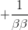is equal is :
2,357 is equal to :
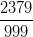
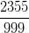
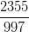
none of these
If the second term of a G.P. is 2 and the sum of its infinite terms is 8, then its first therm is :
2
4
6
8
(1+2+3+….+n) is equal to :
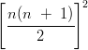
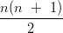
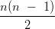
For an – 7n – 1 is divisible by :
50
49
51
48
If x = 2 + , then + 6x is equal to :
0
1
2
3
If + ….+ then ….. is equal is :
Determinate is equal to :
is equal to :
- 6
- 110
0
150
If A = then A2 is equal to:
If A = then is equal to :
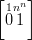
If A and B are the invertible matrix of the required order then the value of will be :
The value of sin 3x is :
The imaginary roots of is :
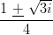
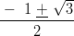
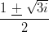
The argument and modulus of the is :
The minimum distance of a point (x, y) from a line ax + by + c = 0, is :
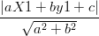
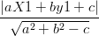
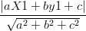
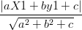
A straight line through ( 1, 1) and parallel to the line 2x + 3y – 7 = 0 is :
2x + 3y + 5 = 0
3x – 2y + 7 = 0
3x + 2y – 8 = 0
2x + 3y – 5 = 0
Equation of the straight line passing through the points (-1, 3) and (4, -2) is :
x- y = 3
x + y = 3
x – y = 2
x + y = 2
The general equation of circle passing through the point of intersection of circle S = 0 and line P = 0, is :
6S + 4P = 0
3S + 4P = 0
4S + 5P = 0
The equation of the radial axis of two circle and , is :
If f (x) = cos (log x), then f(x) f(y) – 1 is equal to :
0
f(x+y)
f(xy)
If f(x) = 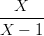= y, then the value of f(y) is :
1 –x
x + 1
x – 1
x
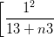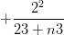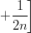is equal to :
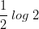
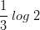
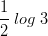
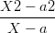is equal to :
0
a
2a
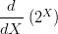is equal to :
1
x log 2
0
Differential coefficient of will be :
(tan x ) is equal to :
sec x tan x
cosec x cot x
The coordinates of the point where the tangent to the curve x2 + y2 – 2x – 3 = 0 is parallel to the axis of x is :
The point at which tangent to the curve y = at the point (0, 1) meets the x-axis is :
(1, 0)
(- ½, 0)
(2, 0)
(0, 2)
Maximum value of slope of a tangent to the curve y = + 2x – 27 will be :
11
- 4
5
2
m 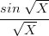dx is equal to :
Correct statement is :
If the matrix P =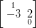 and Q 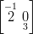then the correct statement is :

